Year End Workshop
2016

Prepared by Chris Diltz
January 9, 2017

Table of Contents
About This Workshop 3
Agenda 4
Order of Application Closures 5
Closing Recommendations 6
Review Setup and Configuration 7
GL Account Classes 7
Ledger Definition 8
Company Definition 9
Closing Document 11
Journal Code 12
Sequence Numbers 14
Year End Processing Steps 16
Closing Phases 16
Year End Check Lists 17
Year End Expense Accruals 20
Year End Reconciliations 26
Close and Manage Periods 27
Reopening Closed Periods 30
Year End Simulation 31
Pre-Closing Verification Report 33
Pre-Closing Considerations 34
Close Year 35

About This Workshop

Topics
- Year End Procedures and Checklists
- Year End Process Overview
- Modernizing Financial Reports
- New Enhancements

Objective
This year end Workshop provides an overall review of the configuration in Sage X3 that affects year end closing as well as the standard steps for completing a year end closing. At the completion of this Workshop our goal is that you will:
- Develop a better understanding of the year end functions in X3
- Have knowledge and checklists to close the year end in your X3 system
- Understand new financial features offered in the latest X3 release

Agenda
Jan 9th Workshop - Times Are Pacific Time Zone

Jan 9th Workshop - East Coast Times
Eastern Schedule [Workshop Schedule 12 Noon EST to 4:00pm EST]
12 Noon EST Introduction, Order of Closing Modules,
Closing Recommendations
12:15 am EST Review Setup and Configuration
12:30 am EST Year End Check Lists
2:00 pm EST Year End Functions and Closing
2:15 pm EST Q&A
2:30 pm EST X3 Product Schedule and Upgrades
3:00 pm EST End of Workshop

Jan 9th Workshop - West Coast Times
Pacific Schedule [Workshop Schedule 9:00am PST to 1:00pm PST]
9:00 am PST Introduction, Order of Closing Modules,
Closing Recommendations
9:15 am PST Review Setup and Configuration
9:30 am PST Year End Check Lists
10:00 am PST Year End Functions and Closing
11:15 am PST Q&A
11:30 pm PST X3 Product Schedule and Upgrades
12:00 pm PST End of Workshop

Order of Application Closures
If you are running modules not on this list (i.e. Fixed Assets) or a third party product, there may be special considerations involved in year-end closing. Please contact the SWK Help Desk or your SWK X3 Consultant for assistance.

Distribution and Manufacturing

Purchasing
Sales
Manufacturing
Inventory

Finance

Accounts Payable
Accounts Receivable
Bank and Cash
General Ledger

Closing Recommendations
Month-end and year-end are important milestones in your ERP system. The closing process is a point in time designated as a “cut-off” for reporting financial statements, operational results as well as regulated reporting such as sales and use tax.
Here are a few recommendations to help you be prepared for closing Sage X3.

Schedule Ahead of Time
Scheduling your period end tasks is as important as performing them. This Workshop will provide you with some check lists to support your period end process. It will be important to review them and order the check list steps for your organization’s needs. Putting these tasks into your calendar and assigning them to team resources will be important to ensure your period close is completed in a reasonable amount of time.
Utilize Available Resources
Coming to the Workshop is a great start to learning about the period end steps for Sage X3. In addition to the Workshop you can contact our SWK Help Desk for specific questions or schedule an appointment with one of our consultants to assist with your period end business processes.
Review Setup
Options in Sage X3 will determine how your period end close is performed by the application. This Workshop will provide a list of the basic setup items to make note of. Other settings in your system may affect your period end close, including Sequence numbers for transactions. If you have questions about other settings not covered in this Workshop, please contact our SWK Help Desk.
1099 Information
Review your Supplier records early to make sure you have their 1099 information setup correctly on their records. Make a list of any Suppliers that weren’t setup correctly during the year so you can review payments and invoices to manually edit their 1099 amounts.

Review Setup and Configuration

GL Account Classes
[Setup > Financials > Account classes]
Account classes must be setup correctly in the right category. They must also be assigned to the accounts correctly. This is important in determining whether or not to carry forward opening balances into a new year.
- Version 6.5 and below Screen Layout
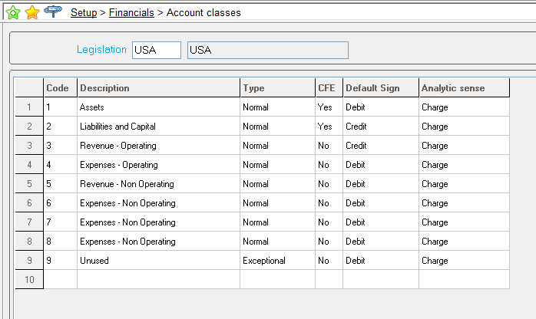
- Version 7 and above Screen Layout
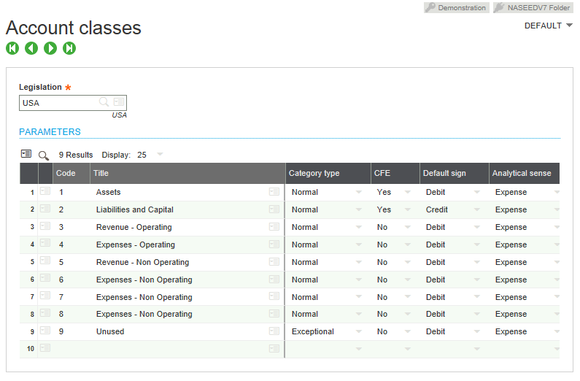

Ledger Definition
[Setup > Organizational structure > Ledgers]
The ledger in X3 maintains the account balances. It also controls how the year end is processed. Choose between closing at the financial site or company level. Also choose if you want a closing document generated. SWK always recommends setting up the Ledger to close by Site and not Company when you have multiple financial sites.
- Version 6.5 and below Screen Layout
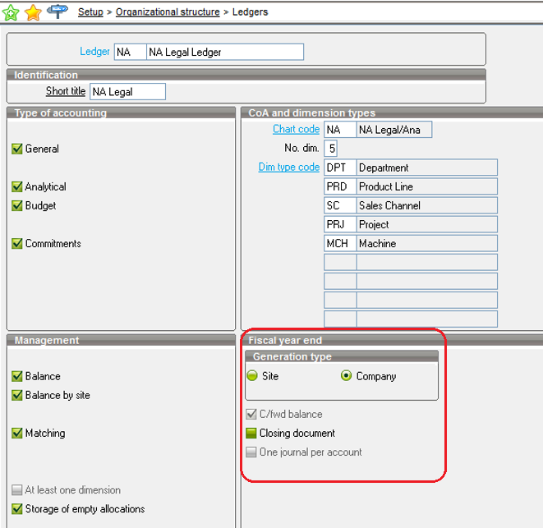
- Version 7 and above Screen Layout
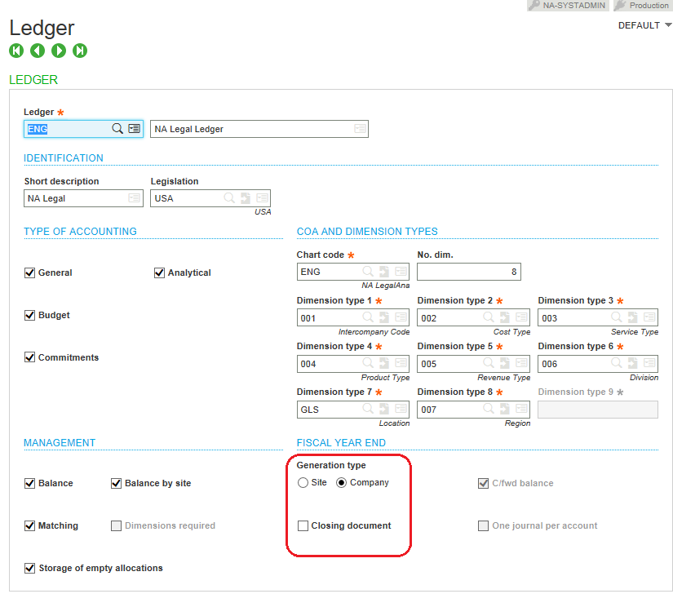

Company Definition
[Setup > Organizational structure > Companies]
If multiple financial sites exist and your ledger is set to close by Company, the Main Site will be used for closing the period balances. SWK always recommends setting up the Ledger to close by Site and not Company when you have multiple financial sites.
- Version 6.5 and below Screen Layout
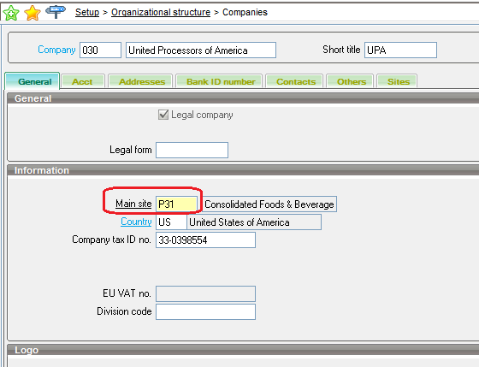
- Version 7 and above Screen Layout
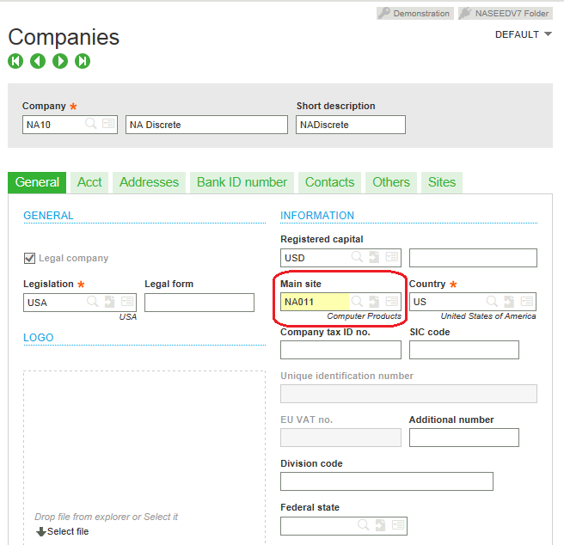

Closing Document
[Setup > Financials > Document types]
A closing document must be setup for X3 to perform year end. Even if you are not having X3 create a closing document. The closing document is usually called NEWPR (new period).
- Version 6.5 and below Screen Layout
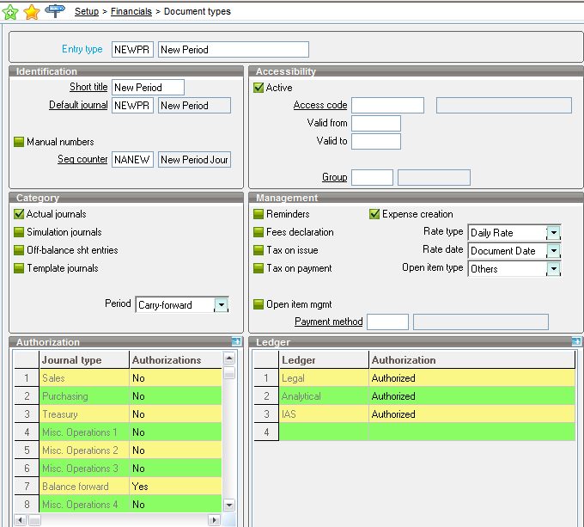
- Version 7 and above Screen Layout (Image 1)
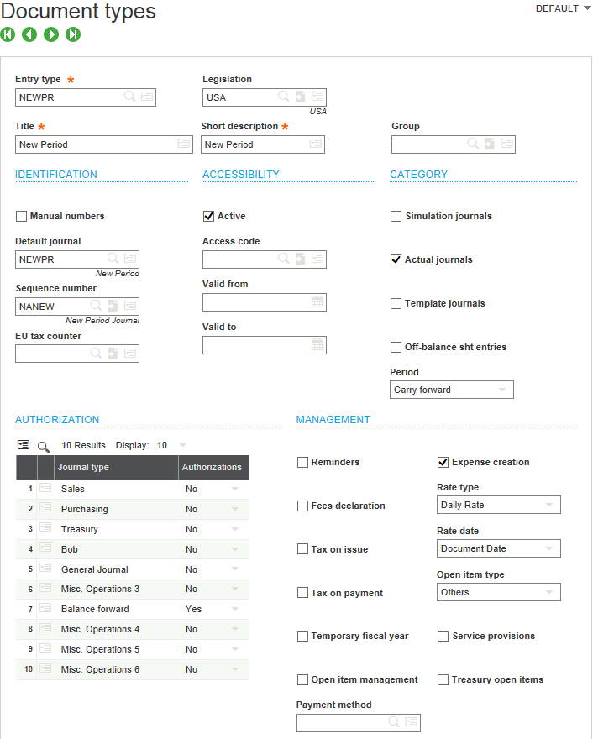

Journal Code
[Common Data > G/L Accounting Tables > General > Journal Codes]
A journal code is assigned to the closing document and must be setup and active for X3 to perform year end. Even if you are not having X3 create a closing document. The journal code is usually called NEWPR (new period).
- Version 6.5 and below Screen Layout
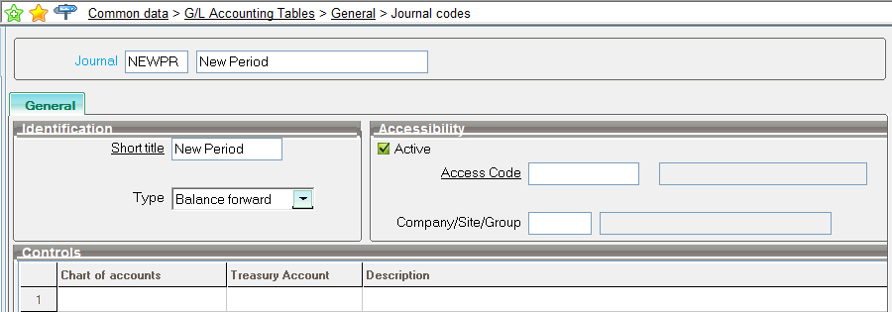
- Version 7 and above Screen Layout
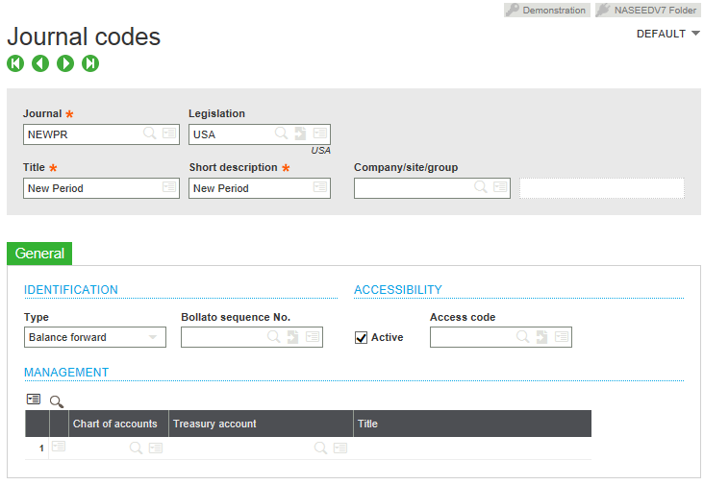

Sequence Numbers
[Setup > General Parameters > Sequence Number definition > Structures]
A sequence number is assigned to the closing document type and must be setup and active for X3 to perform year end. Even if you are not having X3 create a closing document. The sequence number is usually called NEWPR (new period).
- Version 6.5 and below Screen Layout
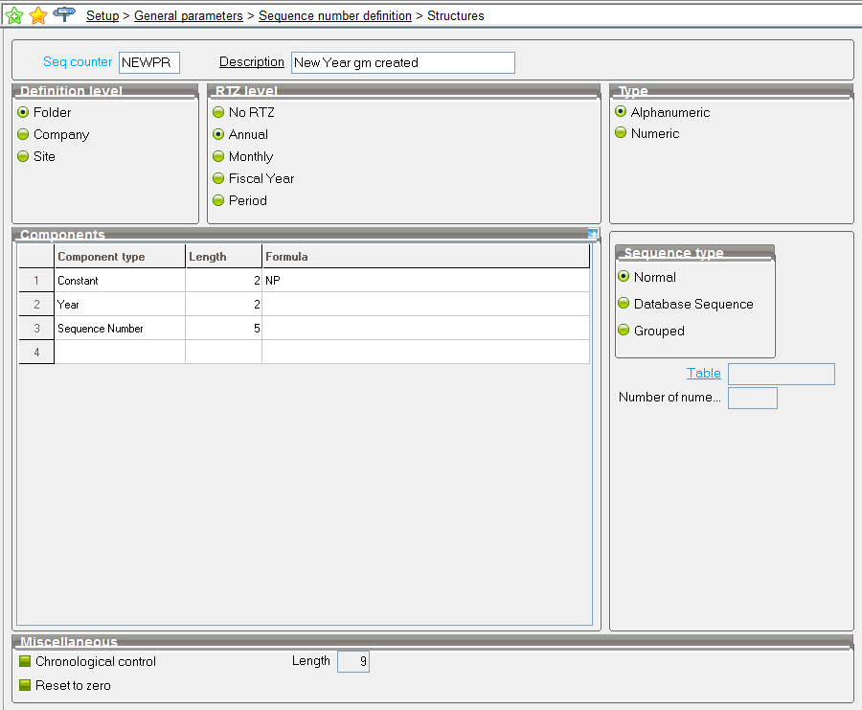
- Version 7 and above Screen Layout
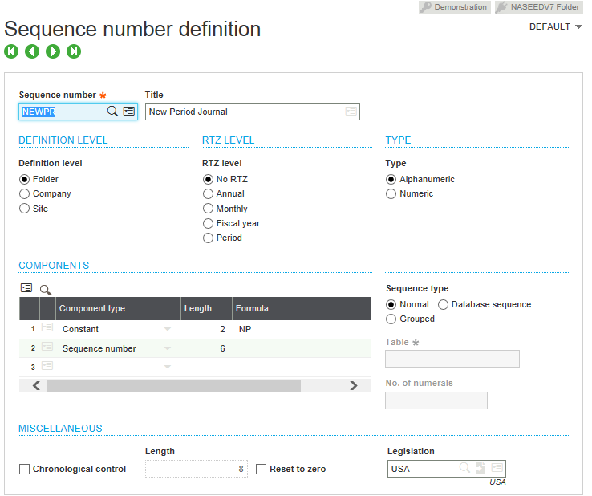

Year End Processing Steps

Closing Phases
The closing steps we recommend are broken out into phases.
Closing Phases | Description
Data Entry & Reporting | All transactions should be entered in the system for the period. Once transactions are entered for the period, run reports for the module to review completeness and accuracy.
Post Data | After all transactions are entered and reviewed, post and validate the transactions. This will move the transactions to the General Ledger.
Functions | Some application functions need to be run to process data and complete posting of data for the period.
Review Steps | After all data is validated, posted and processed in the modules, run your internal review steps to analyze the data.
GL Finalization | Enter transactions and run functions in the general ledger to finalize journal entries and account balances.
GL Reporting | Run your general ledger, financials and the X3 pre-closing reports.
Closing | Close the period, run the year end procedures.

Year End Check Lists

Summary of Check Lists

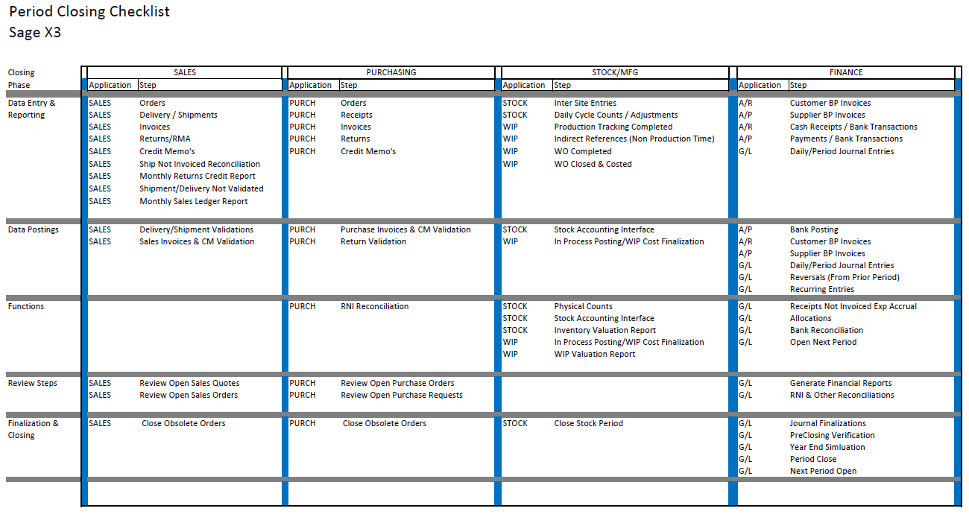

Sales Check List

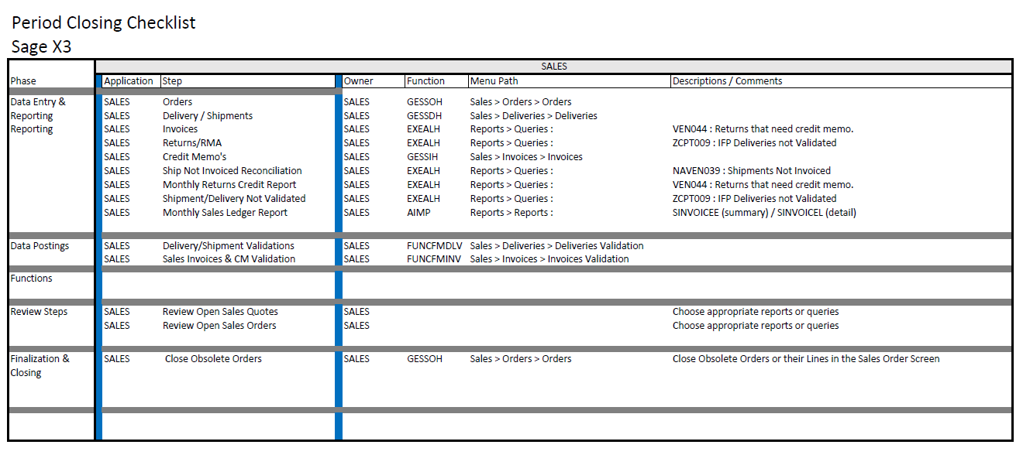

Purchasing Check List

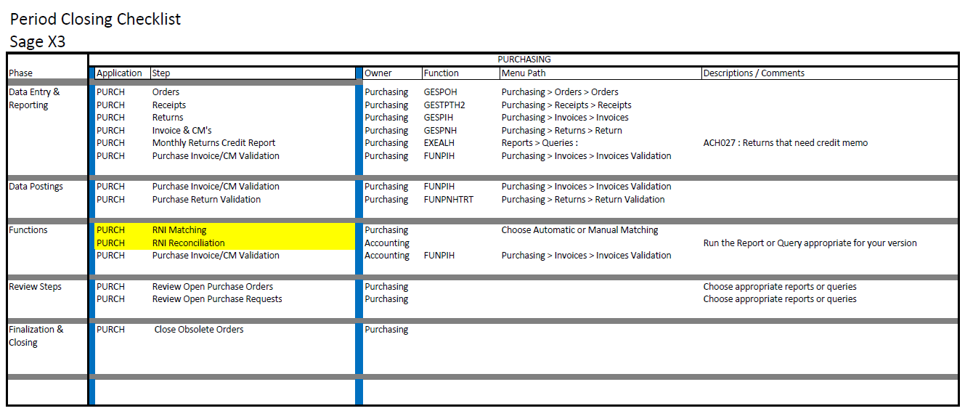

Inventory & Manufacturing Check List

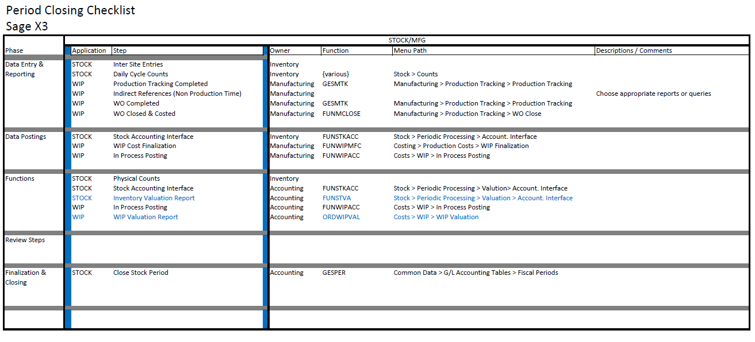

Financials Check List

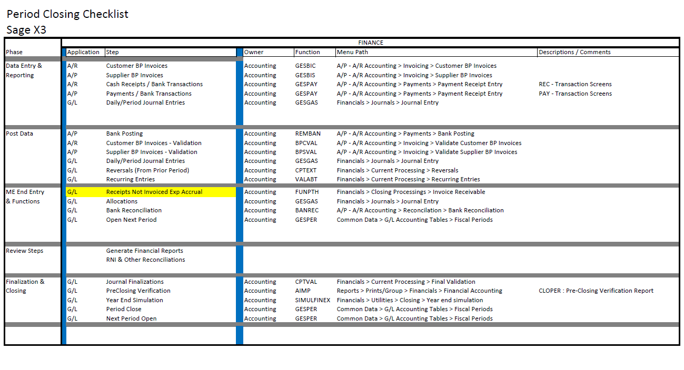

Year End Expense Accruals
In this workshop will review the Invoices Receivable function in X3 that will can calculate expense accruals for purchase receipts of non-managed items that have not yet been invoiced. It is important to note that this review covers non-managed (direct expensed) receipt lines.

Requirements
- Product Records
  - Purchase orders are entered for product records that are marked as “Non Managed”
  - We recommend the product record has the “Received product” box flagged
- Supplier Records
  - The supplier accounting code must have the RNI account setup on the accounting code

Process
- The account number for the non-managed item on each PO line is debited when the expense accrual is processed in the General Ledger.
- The quantity multiplied against the unit price on each PO line is calculated as the Received Qty – Invoiced Qty
- The receipt date is analyzed during the accrual process to determine the period to post the accrual to
Supporting Queries
Query ACH033 “Receipts not invoiced” and ACH040 “Receipt Lines not Invoiced” can be run before the accrual process to report what would be accrued.

ACH033 “Receipts not invoiced”

- Version 6.5 and below Screen Layout
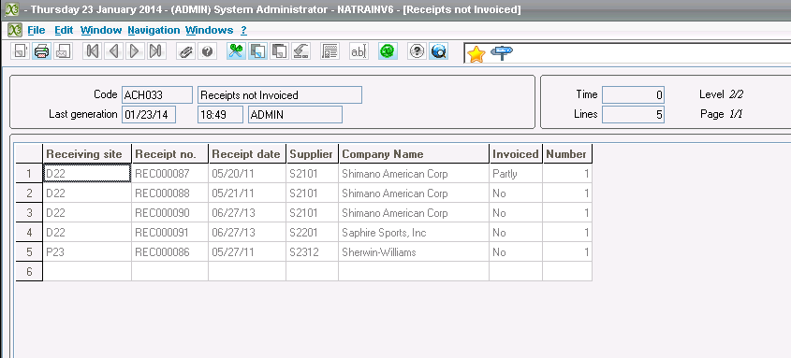
- Version 7 and above Screen Layout
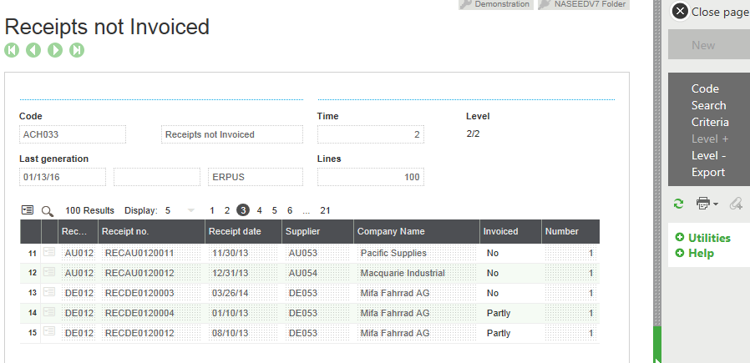
ACH040 “Receipt Lines not Invoiced”

- Version 6.5 and below Screen Layout
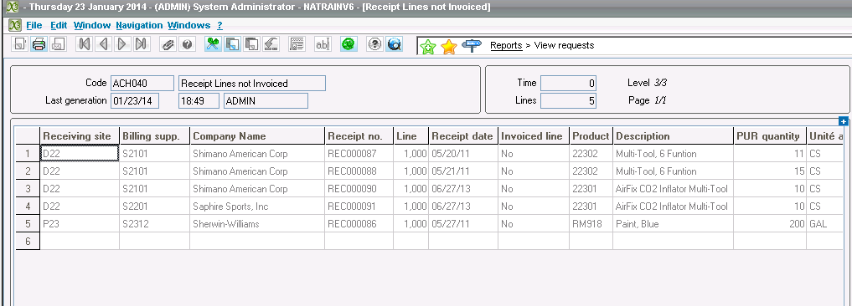
- Version 7 and above Screen Layout
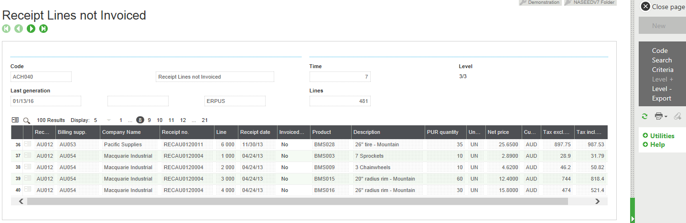

Invoices Receivable
[Financials > Closing processings > Invoices receivable]
- Version 6.5 and below Screen Layout
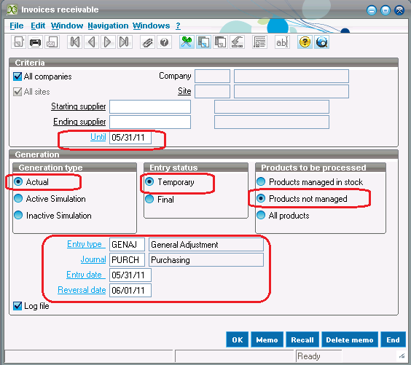
- Version 7 and above Screen Layout
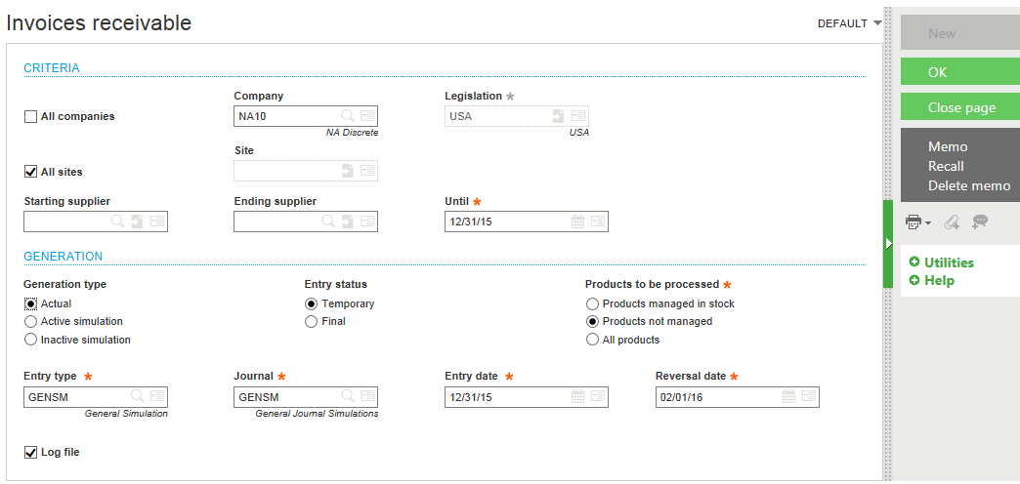

Sample Invoice Receivable Log File
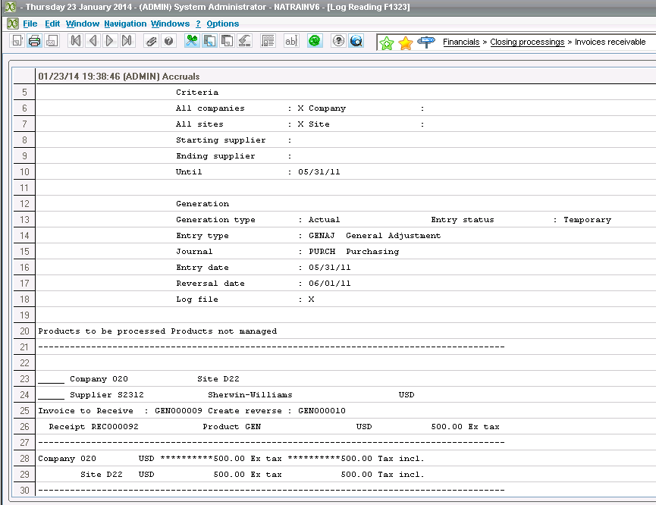

Sample Accrual G/L Entry
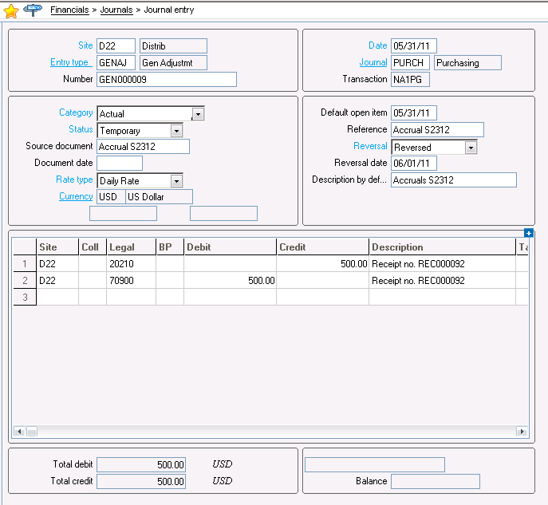
Sample Reversing G/L Entry
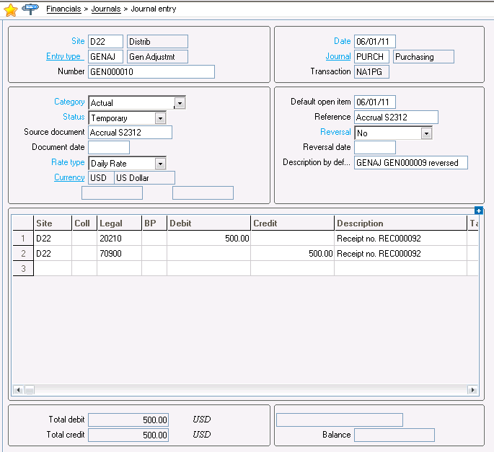

Year End Reconciliations
The year-end process involves reconciling many GL accounts including Cash, Inventory, Receivables, Payables, Receipts Not Invoiced (RNI) and other.

In this workshop we are going to discuss the concept for the RNI account reconciliation as an example of the matching feature in X3 that can support various account reconciliations. If you need a review of procedures to reconcile another account, reach out to the SWK Help Desk or your SWK X3 Consultant.

RNI Account
The Received Not Invoiced (RNI) account is a liability clearing account that represents the value of the inventory that has been received but not yet invoiced. It is updated at time of receiving and invoicing. In order to verify that the RNI account balance is correct, the RNI account transactions need to be reconciled with the purchase order module. This is done by reviewing receipts that have not been invoiced and any variances between the receipt and the invoice.

Depending on your version of X3, you might have different reports or queries to view the unmatched receipt values at period end. These display the amounts you use to reconcile the RNI account.
- RNI Report is used when using Version 6 Patch 15 and below
- Queries are used when using version 6 Patch 16 and above (Including Version 7)

RNI Matching
There are two ways to match the RNI account:

- Automatic Matching
  - The automatic matching utility can be run at the period end to match up receipts to invoices. It can also be executed daily, weekly, or as needed during the month.
  - Automatic Matching looks at journal transactions created by receipts and invoices and matches them based on the description field (receipt/document number).
- Manual Matching
  - Manual Matching may also be used to specifically match receipts to invoices through a user managed and manual process.

Accounts Inquiry
[Financials > Inquiries > Accounts]
Any unmatched and matched account transactions can be viewed in the Accounts Inquiry screen. The criteria button has an option to select matched or unmatched.

Additional Applications
The process and functions in X3 used to reconcile the RNI account can be used across other accounts. For example, freight charged to a customer that is matched to the freight bill from the supplier. By using the matching control available on the GL accounts, X3 can support other reconciliations that you may be performing manually outside of the system.

Contact your SWK X3 Consultant if you would like more information about this functionality.

Close and Manage Periods
Use the Fiscal periods (GESPER) function to close a fiscal period.
[Common Data > G/L Accounting Tables > Fiscal Periods]
- Version 6.5 and below Screen Layout
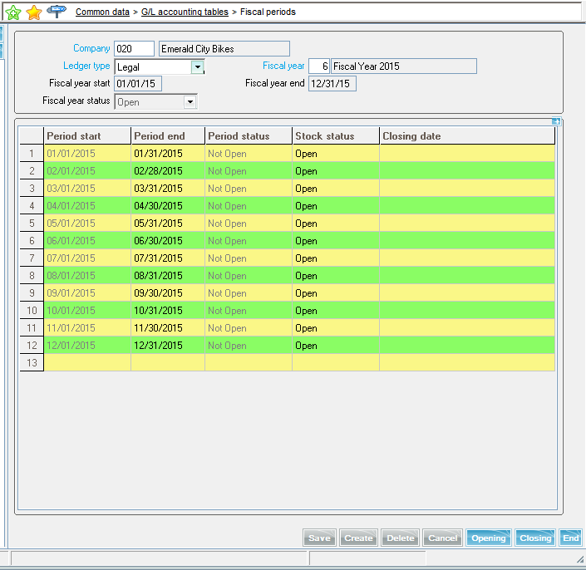
- Version 7 and above Screen Layout
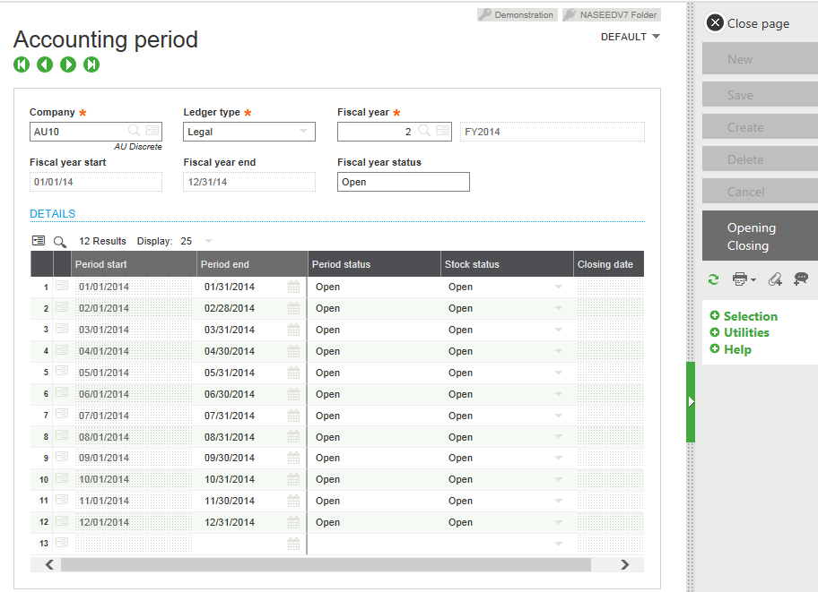
Period Status
There are two columns in Fiscal periods that show the status of any period.

- Period status. This column specifies whether the period is open or closed.
  - To open a period, click Opening in the Actions panel.
  - You can open one period or multiple periods, up to a maximum of 20 periods.
  - You can open periods only within an open fiscal year.
- Stock status. This column specifies if the period is open to any stock movement. Stock movements include such transactions as adjustments, receipts, and shipments. The statuses available are:
  - Open. You can post inventory to the period.
  - Balance adjustment. The period is open only to stock adjustment transactions.
  - Closed. The period is closed to stock adjustments. An error message appears if you try to post to a prior closed period.
Opening and Closing Buttons
Use the Opening button to activate future periods. Use the Closing button to close the period.
Note: The stock status column has a drop down box to open or close period for stock movements.

To close the last period of a year
1. Ask all users to log out of Sage ERP X3.
2. Open Common data >G/L accounting tables > Fiscal periods (GESPER).
3. In the Company field, specify the company.
4. In the Ledger type field, select the ledger.
5. In the Fiscal year
When closing the last period of a fiscal year, a warning message appears alerting you that this is the last period. After running the process, a log file appears that summarizes the operations completed during processing.
Checks Performed on Last Period
When closing the last period of a fiscal year, a warning message appears alerting you that this is the last period.
Sage ERP X3 checks the following information when closing the last period.
- Verifies that the general ledger is balanced.
- Verifies that accruals have been generated.
- Verifies the analytical accounts.
- Verifies that the depreciation expense has been generated if using Fixed Assets.

Procedural Notes
Periods are closed for a specific company, ledger type, and fiscal year.
- You can close more than one period at a time.
- You must close all periods to close the fiscal year.
- After closing a period, you cannot create, modify, or delete journal entries in that period.
- You cannot close a period in the Fiscal periods (GESPER) function. However, you can reopen a closed period in the Fiscal year management (GESFIY) function.

After you close a period, a log file appears and confirms that the period was closed successfully. If the period was not closed successfully, a list displays the items you need to process before the period can be closed.

Reopening Closed Periods

Use the Re-open period (OPNPER) function to reopen a closed period. Once you are finished posting your general ledger entries, you can run period end to the period again.
[Financials > Utilities > Closing > Re-open Period]
- Version 6.5 and below Screen Layout
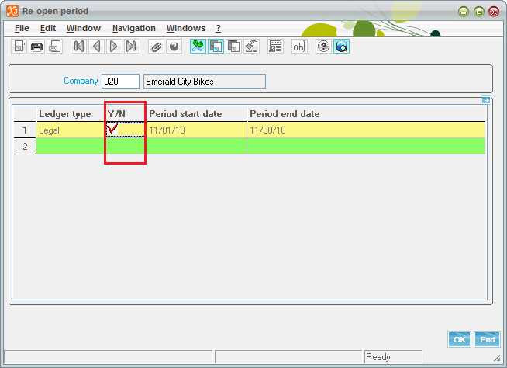
- Version 7 and above Screen Layout
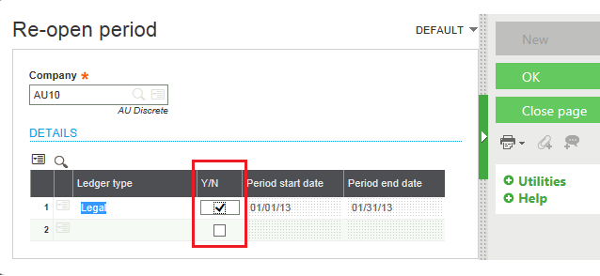

To reopen a closed fiscal period:
1. Open Financials > Utilities > Closing > Re-open period (OPNPER).
2. In the Company field, specify the company.
3. In the Ledger type field, select the ledger.
4. In the Period start date field, specify the start date.
5. Click Close page.

Year End Simulation
Use the Year end simulation (SIMULFINEX) function to move the ending balances on the Trial balance report (NA-TRLBAL) forward without creating the closing journal entries or permanently closing the fiscal year.
[Financials > Utilities > Closing > Year end simulation]
- Version 6.5 and below Screen Layout
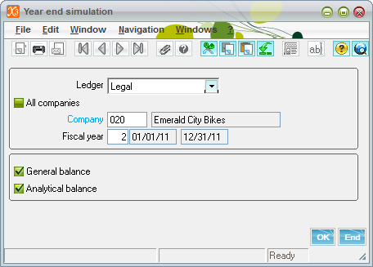
- Version 7 and above Screen Layout
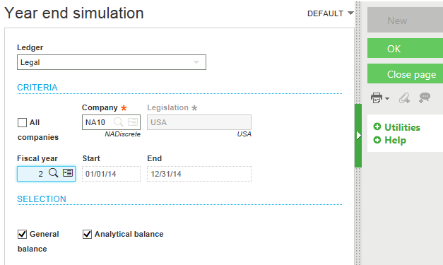
Run this simulation when the previous fiscal year must remain open for a period of time in the current year. By simulating the close, you ensure that monthly statements and the trial balance for the New Year include the correct opening balances. This will maintain the carry forward balances until you are ready to close the previous fiscal year.
- There are no journals created nor is the fiscal year closed, but it will roll the balances forward for any asset or liability accounts.
- If this process is not run, account balances are not carried forward to the New Year and are not reflected on the Trial balance report.

Note the following considerations:
- You can close the year for one company or multiple companies simultaneously, but the simulation can only be run for one company at a time.
- Only one user should be logged into the system to run the simulation. This is same as Year End Close.

To simulate year-end close:
1. Ask all users to log out of Sage ERP X3.
2. Verify that the Accounting task and EDI (Electronic Data Interchange) status monitor are not running.
3. Open Financials > Utilities > Closing > Year end simulation (SIMULFINEX).
4. In the Ledger field, select the ledger.
5. In the Company field, specify the company.
6. In the Fiscal year field, specify the new fiscal year.
7. Select the General balance and Analytical balance check boxes if they are not already selected.
8. Click OK.

After running the process, a log file appears that lists the operations completed during processing.

Pre-Closing Verification Report

Run the Pre-closing verification report (CLOPER) before performing the year-end close. This report lists items you need to address before you close the year.

To run the Pre-closing verification report:
1. Open Reports > Prints/group > Financials > Financial accounting.
2. In the General accounting screen, select Pre-closing verification report (CLOPER).
3. Enter the company and specify the selection criteria.
4. Click Print.

Pre-Closing Considerations

These are some common items that must be completed prior to closing the year. This summary list should be reviewed one last time before proceeding to close the last period and close the year.

- Set SUP General Parameter ENDDAT to 12/31/xx, where xx is a couple of years in the future.
- The next fiscal year must be opened prior to closing the current fiscal year.
- All Purchasing, Sales, Inventory and Manufacturing transactions should be entered.
- Inventory Accounting Interface and Cost In Process Posting functions should be executed.
- All Purchasing, Sales, A/P and A/R invoices must be validated.
- All receipts and payments must be validated (Batch Posting).
- All recurring journal entries must be generated and posted.
- Final Validation must be performed on all journals prior to closing. This is a batch function within G/L Accounting. This will turn all Temporary journals to Final. Also note that if the company is using Simulation journals, there may be other functions to execute prior to Final Validation such as changing the status of simulated journals to Actual journals.
- Price updates for the next year must be entered.
- Close all periods for Current Fiscal Year
- All users must be out of Sage ERP X3.

Note: There is a Pre-Closing verification report named CLOPER that should be run before the year-end close is attempted. This report will list out any open items that need to be addressed before a successful year-end close can be performed.

Close Year
Use the Fiscal year end (FIYEND) function to close a company’s fiscal year and generate the corresponding accounting entries.
[Financials > Closing processings > Fiscal year end]
- Version 6.5 and below Screen Layout
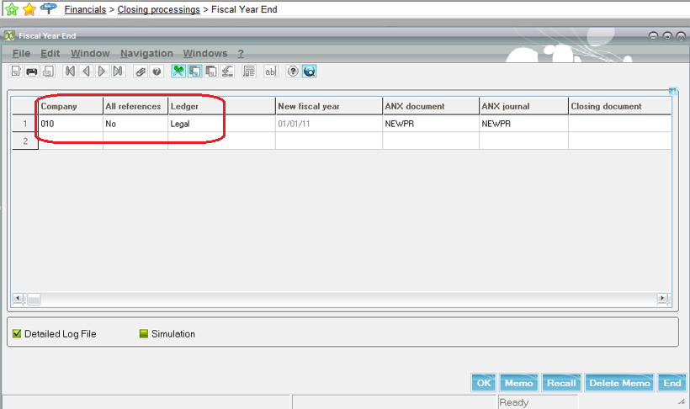
- Version 7 and above Screen Layout
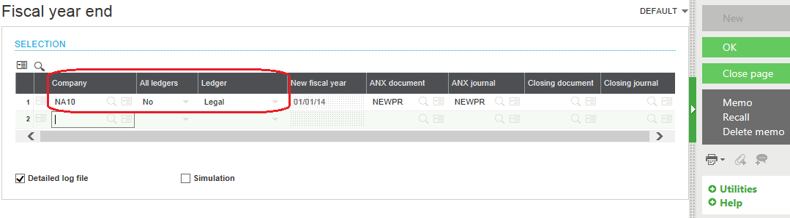
Reminders:
- All users should be out of X3 accept the one performing the Year End close. This is because the Year End Process will shut down the Journal Status Monitor.
- Before you can close a fiscal year, you must close all periods for that year.
- After closing a fiscal year, you cannot post to that year or any periods within it.
- If configured for X3 to create a closing document, the log displays 2 journals with NEWNP document types.
  - The first entry closes out the current fiscal year (Rolls forward Balance Sheet account balances and posts the Net Income/Loss to the New Period Suspense account – ANOUVO).
  - The second entry clears out the New Period Suspense account and DR/CR the Retained Earnings account. In order to view the closing journals, the Journal Status Monitor must be restarted

To close a fiscal year:
1. Ask all users to log out of Sage ERP X3.
2. Open Financials >Closing processings > Fiscal year end (FIYEND).
3. In the Company field, specify the company.
4. In the All ledgers field, select No.
5. Enter the document type and the journal in which the new journals, documents, and invoices will be generated. This is normally NEWPR in both boxes.
6. The Closing document field is blank unless your X3 is configured to generate one.
7. Verify that the start date for the new fiscal year is correct.
8. Select the Detailed log file check box if not already selected.
9. Click OK.

After running the process, a log file appears that lists operations completed during processing. The log file displays two journals if a Closing document was generated.

If your X3 generates closing documents, two sample closing journals are referenced below. These are only shown in the screen for version 6.5 and below:
The first entry closes the current fiscal year. It rolls forward balance sheet account balances and posts the net income/loss to the new Period suspense account (ANOUVO).
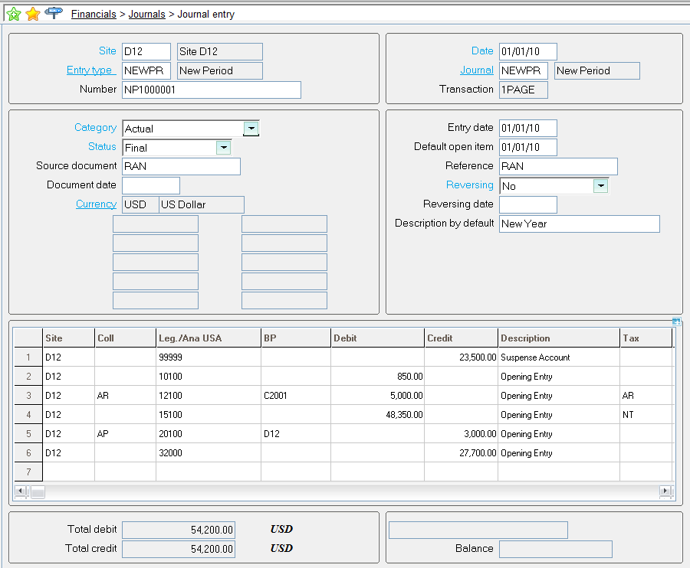

The second entry clears the new Period suspense account and debits/credits the Retained earnings account.

